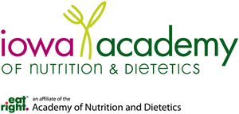

Editor of the Simplified Diet Manual
Position Description

General Description: The position as editor of the Simplified Diet Manual (SDM) is a short term contracted position with the Iowa Academy of Nutrition and Dietetics. The work is compensated according to an agreed upon contract with terms of timing and expense reimbursement. The editor will also receive a complimentary copy of the Manual, the ability to obtain multiple Continuing Education Units from the reading and research done along with the the publication recognition.

Requirements:
- Iowa Academy member
- Past and present use of previous editions of the Simplified Diet Manual

Duties:
- Responsible for the overall preparation of the SDM for publication.
- Oversees discussion/decisions regarding content of SDM; which sections to add, delete, update and revise.
- Identifies contributors to do above; manages signed agreements with contributors;prepares guidelines for contributor submissions to editor; establishes timelines for their contributions; communicates regularly with contributors.
- Obtains copyrights, charts, picture and other content for use in the SDM.
- Works directly with the identified printer.
- Establishes timelines for all components of SDM preparation and completion.
- Communicates regularly with publication committee chair to keep appraised of progress and issues.
- Involved in developing strategies and actions for marketing the SDM in concert with the Iowa Academy Board and marketing team on the Council.
- Following SDM publication, the editor prepares and presents education on the new and updated components of the SDM to various groups who are users and purchasers. Expenses for these efforts will be part of the Iowa Academy budget.

Proposed Compensation: negotiable; previous editor received $7500 plus $1000 for expenses.

